**ABSTRACT**

* Now a days due to advancement of technology, it is difficult to protect creative content and intellectual property.
* It is very easy to copy and modify digital media resulting in great loss in business. So the viable solution for this problem is *DIGITAL WATERMARKING.*
* Digital watermarking is a technique by which we embed copyright mark into digital content which is used to identify the original creator and owner of digital media.
* It is prominently used for tracing copyright infringements. In this project, technique based on *1-LEVEL DISCRETE WAVELET TRANSFORM(DWT)* is used for insertion and extraction of watermark in original image by using *ALPHA BLENDING.* This technique is much simpler and robust than others.

***GENERAL TERMS:***

* Digital Image Watermarking, DWT

***KEYWORDS:***

* Watermark embedding, Watermark extraction, Alpha bending technique.

***SOFTWARE USED:***

MATLAB

**INTRODUCTION**

* Digital media can be copied and modified easily. So protecting the copyright of digital media has become an important task.
* The digital watermark is introduced to solve the problem of copyright. The digital watermarking is a technique of embedding any watermark image into cover image using some known algorithm depending upon the requirement in multimedia data to identify the owner of the document.
* There are two common methods for watermarking:

1. Spatial domain

2. Transform domain.

* In Spatial domain pixels of an image are modified depending upon perceptual analysis of an image.
* In Transform domain some frequencies are selected and modified from their original values according to certain rules. The transform domain methods are more popular because watermark embedding is more robust in this domain as compared to spatial domain.
* It also provides more security and imperceptibility.In this project, we propose the watermarking scheme based on DWT (discrete wavelet transform) which works in transform domain.
* Watermarking algorithms are divided into two groups based on extraction: Blind and Non-blind watermarking.
* In blind watermarking, extraction does not need original image but in non-blind watermarking original image is needed in watermark extraction. We use non-blind watermarking in this project.

**OBJECTIVE OF WATERMARKING**

* With the growth of the internet, unauthorized copying and distribution of digital media has never been easier.
* Normally an application is developed by a person or a small group of people and used by many.
* Hackers are the people who tend to change the original application by modifying it or use the same application to make profits without giving credit to the owner.
* So, we do require a technique called WATERMARKING which can protect our data from unauthorized copying and distribution and can provide copyright owner identification for our digital data over internet.

**PROPERTIES OF DIGITAL WATERMARKING**

TRANSPARENCY OR FIDELITY:

*The digital watermark should not affect the quality of the original image after it is watermarked. Watermarking should not introduce visible distortions because if such distortions are introduced it reduces the commercial value of the image.*

ROBUSTNESS:

*Watermarks could be removed intentionally or unintentionally by simple image processing operations like contrast or brightness enhancement, gamma correction etc. hence watermarks should be robust against variety of such attacks.*

CAPACITY OR DATA PAYLOAD:

*This property describes how much data should be embedded as a watermark to successfully detect during extraction. watermark should be able to carry enough information to represent the uniqueness of the image. different application has different payload requirements*.

**DISCRETE WAVELET TRANSFORM**

* Discrete Wavelet Transform(DWT) is a multiresolution decomposition of a signal. It hierarchically decomposes an image.
* Mapping an image into a set of coefficients is done by Discrete Wavelet Transform. Basically non stationary signals are processed by Discrete Wavelet Transform.
* Both frequency and spatial domain of an image are provided By Discrete Wavelet Transform i.e. It captures both frequency and location information.
* In this, decoding is done in low resolution to high resolution manner. High and low frequency parts are obtained on decomposing an image by DWT.
* Information about edge components are contained in high frequency parts and, low frequency parts again decomposed into another set of low and high frequency parts.
* The image is divided into four multiresolution sub-bands LL, LH, HL and HH using DWT.
* Fine-scale DWT coefficients are represented by LH, HL, HH sub-bands and coarse-scale DWT coefficients are represented by LL sub-bands.
* LL sub-band is further decomposed into four multiresolution sub-bands to obtain next coarser wavelet coefficients. This process is repeated several times determined by application for which it is used.
* In this project, we used 1-level DWT which decomposes an image into LL1 which is lower resolution approximation coefficient and LH1, HL1, HH1 which are detailed components of an image.

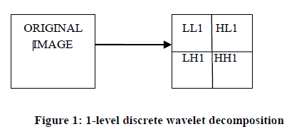

* Discrete wavelet transform is used in many applications related to signal processing such as compression of audio and video, also used in noise removal.
* It provides high compression ratio with good quality of reconstruction.

**WATERMARK EMBEDDING**

* To hide personal data into cover image in perceptually visible manner is the main purpose of the project. A mathematical tool Discrete Wavelet Transform is selected to achieve this object.
* Wavelet domain watermarking is used because it reduces the risk of any distortions such as compression and low pass filtering that changes the high frequency components of an image but it cannot resist attacks that destroy the whole watermarked image such as cropping.
* In this, first we take cover image and decompose it into four components i.e. low frequency approximation, high frequency diagonal, low frequency horizontal, low frequency vertical components using 2D DWT.
* The same procedure is applied on the watermark image which is to be embedded into cover image.
* Now *ALPHA BLENDING* technique is used for inserting a watermark in cover image. In this first we apply DWT to both cover and watermark image to obtain decomposed components which are further multiplied by a particular scaling factor and are added.
* We cannot embed the watermark directly into cover image wavelet coefficients; we embed wavelet coefficients of watermark image into cover image because approximation wavelet coefficients contain more information of original watermark image.
* Here we want watermark to be perceptible or visible in nature, so we embed watermark in low frequency approximation component of cover image.
* Then to generate secure watermarked image, Inverse Discrete Transform is applied to watermarked image coefficient.

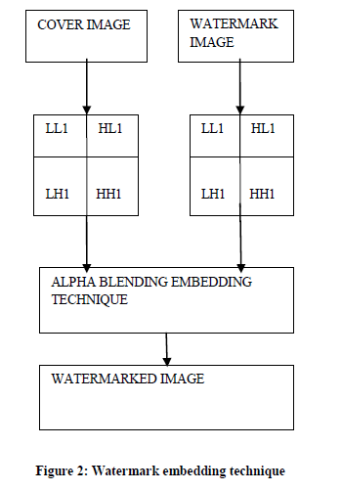

***ALPHA BLENDING***

* Alpha blending is the process of combining an image with a background to create the appearance of partial or full transparency.

* The formula of alpha blending used for watermarking embedding is:

*Watermarked image= A*(LL1) + B*(WM1)*

A, B= scaling factors for cover and watermark image respectively

LL1=low frequency approximation of cover image

WM1= watermark image

**WATERMARK EXTRACTION**

* In this,watermarked image and cover image both are decomposed into their sub bands by applying DWT to both images.
* Now we use cover image to extract the watermark image using non-blind watermarking.
* Then *ALPHA BLENDING* formula is applied to recover the watermark image form watermarked image.
* Here low frequency approximation component of cover image is first multiplied by a particular scaling factor and then subtracted from watermarked image coefficient. To generate the final watermark extracted image, Inverse Discrete Transform is applied to watermark image coefficient.

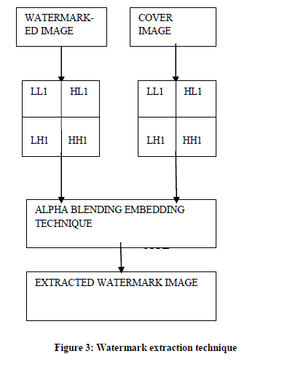

***ALPHA BLENDING***

* The alpha blending formula used for watermark extraction is:

*Recovered watermark = (WM - A*LL1)*

WM=Watermarked image

A= scaling factor for cover image

LL1= Low frequency approximation component of cover image

**MATLAB CODE**

***Embedding Watermark into original image to get watermarked image***

clc

close all

%host(original image)

rgbimage=imread('host.jpg');

figure;

imshow(rgbimage);

title('original color image');

[h_LL,h_LH,h_HL,h_HH]=dwt2(rgbimage,'haar');

dec2d = [...

h_LL, h_LH; ...

h_HL, h_HH ...

];

figure;

imshow(uint8(dec2d));

title('DWT2 of original color image');

%watermark(image to be watermarked)

rgbimage=imread('watermark.jpg');

figure;

imshow(rgbimage);

title('watermark image');

[w_LL,w_LH,w_HL,w_HH]=dwt2(rgbimage,'haar');

dec2d = [...

w_LL, w_LH; ...

w_HL, w_HH ...

];

figure;

imshow(uint8(dec2d));

title('DWT2 of Watermark image');

%watermarking

newhost_LL = (0.2*h_LL) + (0.30*w_LL);

%output

rgb2=idwt2(newhost_LL,h_LH,h_HL,h_HH,'haar');

figure;

imshow(uint8(rgb2));

title('Watermarked image for A=0.4');

imwrite(uint8(rgb2),'Watermarked.jpg');

newhost_LL = (0.4*h_LL) + (0.30*w_LL);

%output

rgb2=idwt2(newhost_LL,h_LH,h_HL,h_HH,'haar');

figure;

imshow(uint8(rgb2));

title('Watermarked image for A=0.6');

imwrite(uint8(rgb2),'Watermarked.jpg');

newhost_LL = (0.7*h_LL) + (0.30*w_LL);

%output

rgb2=idwt2(newhost_LL,h_LH,h_HL,h_HH,'haar');

figure;

imshow(uint8(rgb2));

title('Watermarked image for A=0.8');

imwrite(uint8(rgb2),'Watermarked.jpg');

newhost_LL = (1*h_LL) + (0.30*w_LL);

%output

rgb2=idwt2(newhost_LL,h_LH,h_HL,h_HH,'haar');

figure;

imshow(uint8(rgb2));

title('Watermarked image for A=1');

imwrite(uint8(rgb2),'Watermarked.jpg');

newhost_LL = (2*h_LL) + (0.30*w_LL);

%output

rgb2=idwt2(newhost_LL,h_LH,h_HL,h_HH,'haar');

figure;

imshow(uint8(rgb2));

title('Watermarked image for A=2');

imwrite(uint8(rgb2),'Watermarked.jpg');

***Extracting Watermark from watermarked image***

clc

close all

%host(original image)

rgbimage=imread('host.jpg');

figure;

imshow(rgbimage);

title('original color image');

[h_LL,h_LH,h_HL,h_HH]=dwt2(rgbimage,'haar');

dec2d = [...

h_LL, h_LH; ...

h_HL, h_HH ...

];

figure;

imshow(uint8(dec2d));

title('DWT2 of original color image');

%watermarked image

rgbimage=imread('watermarked.jpg');

figure;

imshow(rgbimage);

title('Watermarked Image');

[w_LL,w_LH,w_HL,w_HH]=dwt2(rgbimage,'haar');

dec2d = [...

w_LL, w_LH; ...

w_HL, w_HH ...

];

figure;

imshow(uint8(dec2d));

title('DWT2 of Watermark image');

%extracting watermark

extract_LL = (w_LL) - (2.4*h_LL);

%output

rgb2=idwt2(extract_LL,w_LH,w_HL,w_HH,'haar');

figure;

imshow(uint8(rgb2));

title('extracted Watermark for A=2.4 ');

extract_LL = (w_LL) - (1*h_LL);

%output

rgb2=idwt2(extract_LL,w_LH,w_HL,w_HH,'haar');

figure;

imshow(uint8(rgb2));

title('extracted Watermark for A=1 ');

extract_LL = (w_LL) - (0.4*h_LL);

%output

rgb2=idwt2(extract_LL,w_LH,w_HL,w_HH,'haar');

figure;

imshow(uint8(rgb2));

title('extracted Watermark for A=0.4 ');

extract_LL = (w_LL) - (0.2*h_LL);

%output

rgb2=idwt2(extract_LL,w_LH,w_HL,w_HH,'haar');

figure;

imshow(uint8(rgb2));

title('extracted Watermark for A=0.2 ');

**EXPERIMENTAL RESULTS**

* Two grayscale images are used for performing watermarking process. One image is taken as cover image named as host image(chillies) and other is taken as watermark image named fruit image. In this low frequency contents of both images are taken. This technique is called *ALPHA BLENDING*.
* Both images are of equal size. The watermark image is embedded into cover image by varying the value of A from 0.2 to 2..But value of B remains constant. As the value of A decreases below 0.4, watermark image becomes brighter and completely covers and destroys the cover image.
* For recovering the watermark image value of A varies from .9 to .4 depending upon the value of A in embedding algorithm. As value decreases below 0.2, recovered watermark become darker and watermark become completely invisible.
* Below, watermarked images are shown depending upon various values of A and the recovered watermark images are shown as well based on different values of scaling factor A.

***Original Image and Watermark image***

 

 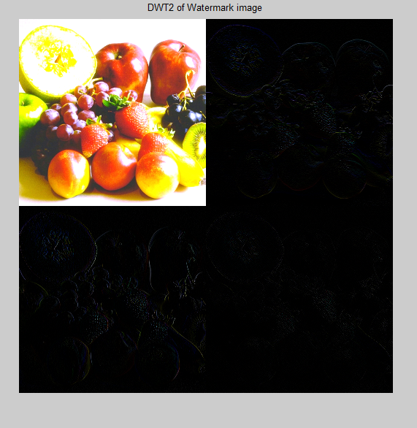

***Watermarked images using various values of scaling factors A and B***

 

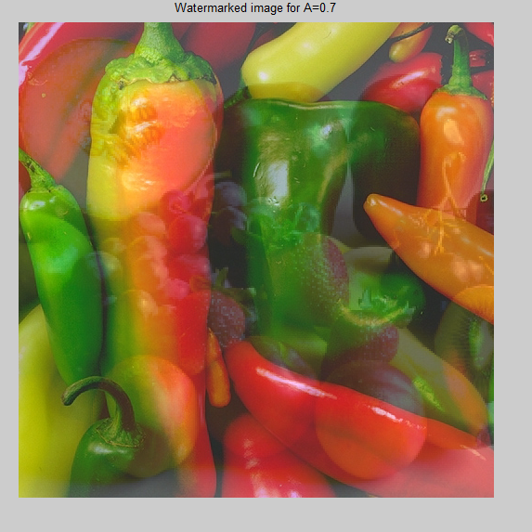 

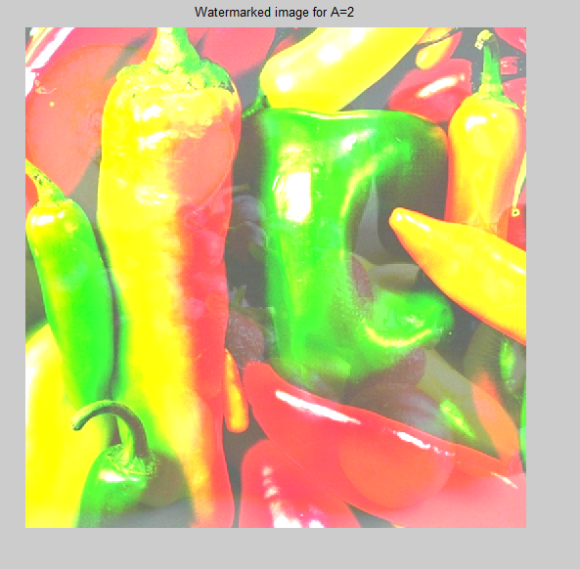

**Recovered watermark for various values of scaling factor**

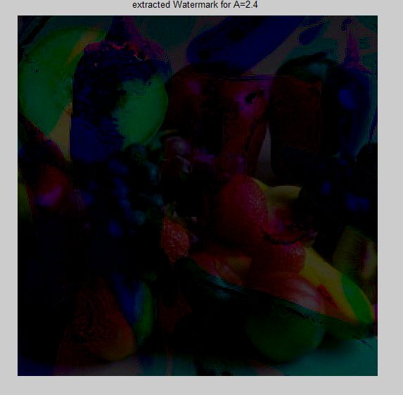 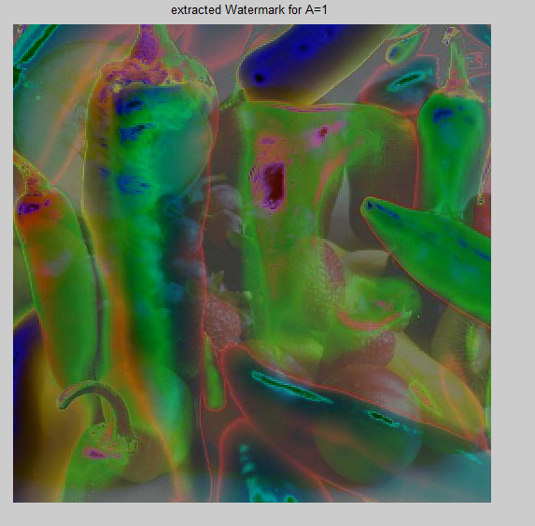

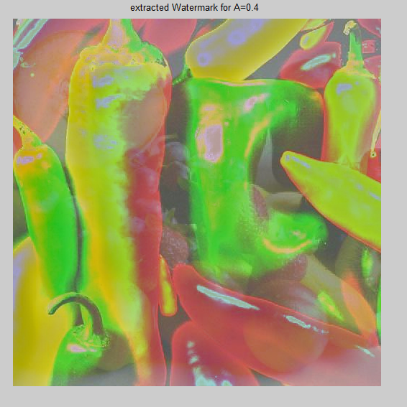 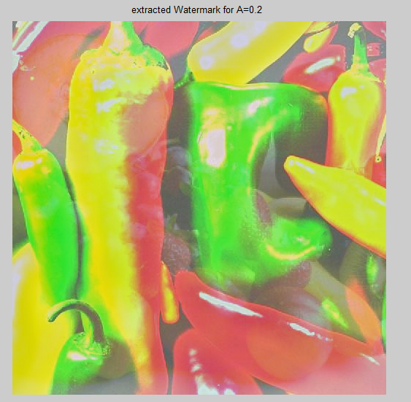

**APPLICATIONS**

* Copyright protection
* Content archiving
* Meta-data insertion
* Broadcast monitoring
* Tamper detection
* Digital fingerprinting
* Medical applications
* Airline traffic monitoring

***Copyright Protection:***Watermarking can be used to protecting redistribution of copyrighted material over the untrusted network like Internet or peer-to-peer (P2P) networks. Content aware networks (P2P) could incorporate watermarking technologies to report or filter out copyrighted material from such networks.

***Content Archiving:***Watermarking can be used to insert digital object identifier or serial number to help archive digital contents like images, audio or video. It can also be used for classifying and organizing digital contents. Normally digital contents are identified by their file names; however, this is a technique as file names can be easily changed. Hence embedding the object identifier within the object itself reduces the possibility of tampering and hence can be effectively used in archiving systems.

***Meta-data Insertion:***Meta-data refers to the data that describes data. Images can be labelled with its content and can be used in search engines. Audio files can carry the lyrics or the name of the singer. Journalists could use photographs of an incident to insert the cover story of the respective news. Medical X-rays could store patient records.

***Broadcast Monitoring:***Broadcast Monitoring refers to the technique of cross-verifying whether the content that was supposed to be broadcasted (on TV or Radio) has really been broadcasted or not. Watermarking can also be used for broadcast monitoring. This has major application is commercial advertisement broadcasting where the entity who is advertising wants to monitor whether their advertisement was actually broadcasted at the right time and for right duration.

***Tamper Detection:***Digital content can be detected for tampering by embedding fragile watermarks. If the fragile watermark is destroyed or degraded, it indicated the presence of tampering and hence the digital content cannot be trusted. Tamper detection is very important for some applications that involve highly sensitive data like satellite imagery or medical imagery.

***Digital Fingerprinting****:* Digital Fingerprinting is a technique used to detect the owner of the digital content. Fingerprints are unique to the owner of the digital data. Hence single digital content can have different fingerprints because they related to different users.

**CONCLUSION**

* In this paper watermarking is done by DWT which is multiresolution technique and the decoding done is hierarchal.
* In this proposed method visible watermark is embed into the cover image and also extracted from cover image with the help of cover image.
* The insertion and extraction of watermark is achieved by DWT (discrete wavelet transform), IDWT (inverse discrete transform) and the *ALPHA BLENDING* technique.
* The scaling factors A, B determines the quality of watermarked image and recovered watermark.

**REFERENCES**

* Akhil Pratap Singh, Agya Mishra, “Wavelet Based Watermarking On Digital Image”, Indian Journal of Computer Science and Engineering, Vol.1, No.2, 86-91.
* Satendra Kumar, Jaydeep Kishore, Nitin Arora,”Enhanced Digital Image Watermarking Scheme Based On DWT and SWD”,International Journal of Computer Applications, Vol.57, No.11, 2012.
* Mohammad Reza Soheili,”A Robust Digital Image Watermarking Scheme Based on DWT, Journal of Computer Engineering 1, 2009.
* Xiang-Gen Xia, Charles G. Boncelet, Gonzalo R. Arce,”Wavelet Transform Based Watermark for Digital Images”, Optical Express 497, Vol. 3, No.12, 1998.